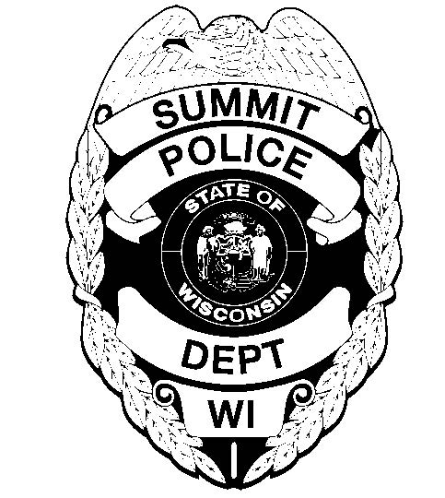

45th Anniversary
Village of Summit Police Officers Line-of-Duty Deaths

2020 is the 45th Anniversary of the Line-of-Duty Deaths of Summit Police Officers Wayne Olson and Robert Atkins, Jr. On Sunday, January 26, 1975, both officers were ambushed and shot to death.

With the 45th Anniversary of this tragedy around the corner, the Summit Police Department is asking for the financial support of the community to purchase a bronze memorial to honor the ultimate sacrifice given by these officers. The memorial is estimated to cost $1,200. If any additional funds were to be collected above the necessary cost, those funds would be used to defray the cost of a display of historic memorabilia of the Summit Police.

Donations can be made to Summit Police Memorial Fund c/o Ixonia State Bank.

